
DEPARTMENT OF INFORMATION AND COMMUNICATION TECHNOLOGY
LABORATORY TASK 5 | SESSION: 2 2024/2025

COURSE CODE: DFT40163 | COURSE NAME: WEB DESIGN TECHNOLOGY
CLO 1: Construct the HTML, CSS, JavaScript and jQuery in developing an interactive web page that can be published on web browser (P4, PLO 3)
TOPIC : 5.0 Web Mobile Framework

NAME :  - NUR AMALINA BINTI BADRULHISHAM  - FATIMAH AZ ZAHRA BINTI ZULKARNAIN  - NURFAYIZAH BINTI OMRKAYAM |  | REGISTRATION NO:  - 10DDT23F1065  - 10DDT23F1015  - 10DDT23F1125
CLASS : DDT4C |  | DURATION : 4 hours

CLO | MARKS
CLO 1P | /52
Total marks | /100

INSTRUCTION:
This laboratory task must be complete as a group consisting of 3-4 group members only. Read the QUESTIONS and refer to attached RUBRIC for MARKING SCHEME carefully.

LAB REPORT FORMAT
Content of the LAB REPORT:
The Lab Report must consist of ALL the question sheets, lab task rubric and all the answers which are arranged according to the page order as has been included.

Warning!
Marks will be deducted for any plagiarism from the total marks achieved.
Instructions:
You are required to construct a mobile-responsive website using the jQuery Mobile framework based on the given reference and the attached design sample (refer to the provided screenshot).
Main Source: https://demos.jquerymobile.com/1.2.0/

Objective
- To creatively apply jQuery Mobile components in building a mobile web application.
- To design a professional landing page for "Jabatan Teknologi Maklumat & Komunikasi (JTMK)".

Task (CLO2: P4)
Construct a mobile web landing page that includes the following components:

1. Header Section
- Organization logo on the left.
- Navigation bar on the right with links: HOME, ABOUT, PROJECTS, and CONTACT.
- The header must be sticky (fixed at the top) on all pages.

2. Main Content Sections

a) HOME Page
- A large introduction section with:
  - Heading: "HEY, MY NAME IS JTMK"
  - Sub-heading describing JTMK:
"JTMK is the Department of Information and Communication Technology (JTMK) offering DDT courses (Diploma in Information Technology (Digital Technology)) at Seberang Perai Polytechnic (PSP)."
- A button labeled "PROJECTS" that links to the Projects page.

b) ABOUT Page
- Details about all group members, assuming these roles:
  - Head of Department
  - Program Head (Software Track)
  - Program Head (Network Track)
  - Program Head (Data Track)
- Each member's profile must include:
  - Passport-sized photo
  - Full name
  - Position
  - Contact number

c) PROJECTS Page
- Create a list of projects with:
  - Project titles
  - Images
  - Reports in PDF format (clickable and viewable)
- Content must be creative and meaningful.

d) CONTACT Page
- Include functional buttons/links for:
  - Phone call (using tel: link)
  - Email (using mailto: link)
  - WhatsApp messaging (using WhatsApp API link)

3. Footer Section
- At the bottom of every page, display centered text:
"Copyright © DDT4x S2 2024/2025. All rights reserved."

4. Additional: Social Media Sidebar (Floating on Left)
- Display clickable icons vertically for:
  - LinkedIn
  - GitHub
  - Twitter
  - YouTube
  - Instagram
- Dummy links (#) are acceptable.

Requirements
- Apply jQuery Mobile components:
  - Header/Footer
  - Navigation Bar
  - Buttons
  - Listviews
  - Responsive Layouts (Grids)
- Apply Mobile Web Apps Architecture:
  - Use roles, theming, and page management.
- Manipulate Dialogs:
  - Apply dialog boxes where suitable according to creativity and page needs.
- Apply Hosting Resources:
  - Local Hosting: Host all files within the project folder (e.g., using FTP upload to web hosting like 000webhost, InfinityFree, GitHub Pages).
  - CDN Hosting: Use appropriate CDN links for libraries (e.g., jQuery, jQuery Mobile).
- Integrate jQuery Mobile lab activities previously done in class wherever relevant.

Deliverables
- Submit the complete project files:
  - HTML, CSS (if applicable), jQuery Mobile files.
- Must be tested and function correctly in both desktop browser and mobile view.
- Include a brief report containing:
  - URL of the developed website
  - Full source code
  - Screenshots of each page in responsive view (both desktop and mobile)
- Submit as a single compressed ZIP file.
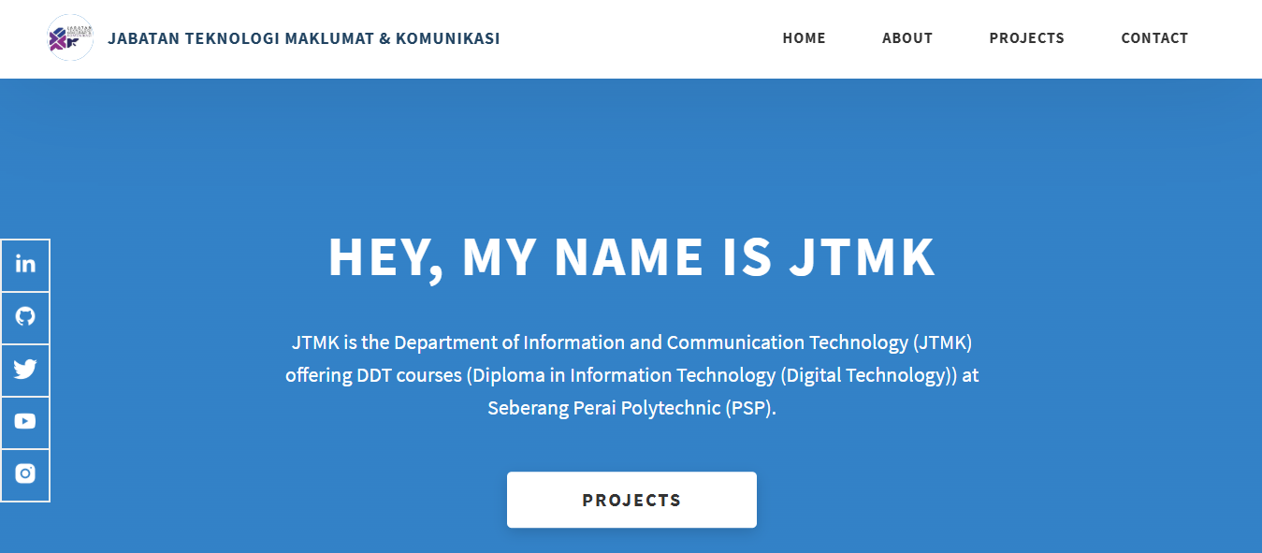
Figure X: Sample Outcome for Homepage (without applying jQuery Mobile components)
This sample shows the homepage layout before integration of jQuery Mobile framework. It lacks mobile responsiveness, theming, and interactive jQuery Mobile elements.

INFORMATION AND COMMUNICATION TECHNOLOGY DEPARTMENT
LABORATORY TASK 5 RUBRIC | SESSION 2 2024/2025
COURSE CODE | DFT40163 | COURSE NAME | WEB DESIGN TECHNOLOGY
ASSESSMENT TASK | LAB TASK 5 | LECTURER’S NAME | EN. MUHAMMAD FAREEZ BIN BORHANUDIN
REGISTRATION NUMBER | - 10DDT23F1065 | STUDENT’S NAME | - NUR AMALINA BINTI BADRULHISHAM
 | - 10DDT23F1015 |  | - FATIMAH AZ ZAHRA BINTI ZULKARNAIN
 | - 10DDT23F1125 |  | - NURFAYIZAH BINTI OMORKAYAM
 | 4 |  | 4

CATEGORY / SCORE | 4 (Excellent) |  | 3 (Good) |  | 2 (Fair) |  | 1 (Poor) | Weight (%) |  | Student Score  (1–4) |  | Marks (Student Score × Weight / Tot. Score)
Design & Layout | Excellent, professional layout; fully responsive and visually appealing |  | Good layout; responsive design with minor flaws |  | Basic structure; limited responsiveness; lacks polish |  | Very poor layout; no clear structure; lacks responsiveness | 15
Use of jQuery Mobile Components | Creative and full application of jQuery Mobile components with enhancements |  | Proper and consistent use of required components |  | Basic components used correctly, but inconsistent |  | Minimal or incorrect use of jQuery Mobile components | 15
Navigation Bar | Fully functional, user-friendly navigation. |  | Function with minor issues. |  | Basic structure, links may not work. |  | Missing or not functional. | 10
Social Media Sidebar (Floating on Left)) | All icons complete, linked correctly. |  | All icons are present and properly linked with minor errors |  | Some icons missing or not properly linked |  | Major icons missing or incomplete | 10
About Us Page Content | Complete, meaningful, professional content. |  | Complete but lacks some quality details. |  | Basic information included but incomplete. |  | Very incomplete or irrelevant. | 5
Project Page Content | Complete, creative, well-documented projects. |  | Good project list with images/PDFs. |  | Few projects with basic info. |  | Very little or no project info. | 5
Footer (Copyright & Alignment) | Footer perfectly formatted and centered. |  | Footer corrects with minor formatting issues. |  | Footer present but not properly centered. |  | Footer missing or incorrectly formatted. | 5
Padding and Margin (Navbar, Content, Footer) | Excellent and consistent padding/margin across pages. |  | Proper padding/margin but slight inconsistency. |  | Basic padding/margin but inconsistent. |  | No proper padding/margin settings. | 5
Direct Call, Email & WhatsApp Functions | All three functions were correctly implemented. |  | Two functions work properly. |  | Only one function works. |  | None implemented. | 5
Hosting (Project Files Hosted) | Properly hosted and fully functional project. |  | Hosting successful with minor issues. |  | Hosting done but many errors. |  | Files not hosted or broken hosting. | 10
CSS Application |  |  |  |  | Good CSS, improves layout. |  | Basic CSS, minimal styling. | 5
Use of CDN |  |  |  |  | Full and proper use of CDN links. |  | CDN used correctly but minor errors. | 5
Report Submission (URL, Source Code, Screenshots) |  |  |  |  | Full report: URL, complete source code, and all responsive screenshots included properly |  | Report submitted but incomplete (missing screenshots/code) | 5
Task Completion within Time Allocated |  |  |  |  | Completed on time, high-quality submission. |  | Late submission but acceptable quality. | 5
TOTAL SCORE ( / 100)
Note: A mark of ZERO (0) will be given if all items for score 1-4 are NOT fulfilled as specified or NO answer is given by the student.

~End of Question~

Answer Sheet:

Hosting (Project Files Hosted)
URL address:

Coding
Note: Font Type Consolas 10pt, Single Spacing
Specify the name of the html file followed by coding.

home.html
<!DOCTYPE html>
<html lang="en">

<head>
<meta charset="UTF-8" />
<meta name="viewport" content="width=device-width, initial-scale=1.0" />
<title>JTMK - Home</title>
<link rel="stylesheet" href="https://cdnjs.cloudflare.com/ajax/libs/font-awesome/6.0.0/css/all.min.css" />
<style>
body {
margin: 0;
font-family: 'Poppins', sans-serif;
background-color: #f4f4f4;
}
.header {
color: #2d8be6;
display: flex;
justify-content: space-between;
align-items: center;
background-color: white;
padding: 20px 0px;
position: fixed;
top: 0;
width: 100%;
z-index: 1000;
box-shadow: 0 2px 5px rgba(0, 0, 0, 0.1);
}
.header .logo {
display: flex;
align-items: center;
}
.header .logo img {
height: 65px;
margin-right: 10px;
}
.header .nav a {
margin-left: 30px;
padding: 0 10px;
text-decoration: none;
color: black;
font-weight: 600;
font-size: 16px;
}
.header .nav a:hover {
color: #2d8be6;
}
.main-content {
background-color: #2d8be6;
color: white;
text-align: center;
padding: 180px 20px 100px;
min-height: 55vh;
}
.main-content h1 {
font-size: 36px;
margin-bottom: 20px;
}
.main-content p {
font-size: 16px;
max-width: 700px;
margin: 0 auto 30px;
line-height: 1.6;
}
.btn {
background-color: white;
color: black;
padding: 12px 30px;
font-weight: bold;
font-size: 14px;
text-decoration: none;
border-radius: 4px;
display: inline-block;
margin: 10px;
}
.btn:hover {
background-color: #f0f0f0;
}
.social-sidebar {
position: fixed;
top: 50%;
left: 0;
transform: translateY(-50%);
display: flex;
flex-direction: column;
z-index: 1000;
}
.social-sidebar a {
padding: 12px;
color: #2d8be6;
background: #fff;
border: 1px solid #ccc;
text-align: center;
transition: background 0.3s;
}
.social-sidebar a:hover {
background: #f0f0f0;
}
.footer-content {
background-color: #e3d9d9;
color: black;
text-align: center;
padding: 1px 0;
font-size: 16px;
}
.dialog-overlay {
position: fixed;
top: 0;
left: 0;
right: 0;
bottom: 0;
background-color: rgba(0, 0, 0, 0.6);
display: none;
justify-content: center;
align-items: center;
z-index: 2000;
}
.dialog-box {
background: white;
color: black;
padding: 30px;
max-width: 500px;
border-radius: 10px;
text-align: center;
}
.dialog-box p {
font-size: 16px;
line-height: 1.6;
}
.close-btn {
margin-top: 20px;
background-color: #2d8be6;
color: white;
padding: 10px 20px;
border: none;
font-weight: bold;
cursor: pointer;
border-radius: 4px;
}
.close-btn:hover {
background-color: #176bbd;
}
@media (max-width: 768px) {
.header {
flex-direction: column;
align-items: flex-start;
padding: 15px;
}
.header .nav {
margin-top: 10px;
}
.header .nav a {
margin-left: 0;
margin-right: 15px;
}
.main-content h1 {
font-size: 28px;
}
.main-content {
padding: 160px 20px 80px;
}
}
</style>
</head>
<body>
<!-- Social Media Sidebar -->
<div class="social-sidebar">
<a href="#"><i class="fab fa-linkedin-in"></i></a>
<a href="#"><i class="fab fa-github"></i></a>
<a href="#"><i class="fab fa-twitter"></i></a>
<a href="#"><i class="fab fa-youtube"></i></a>
<a href="#"><i class="fab fa-instagram"></i></a>
</div>
<!-- Header -->
<div class="header">
<div class="logo">
<img src="https://encrypted-tbn0.gstatic.com/images?q=tbn:ANd9GcROyv4Nw0BIjqcgF-J1VsyBbg3NfMots20uQQ&s"
alt="Logo" />
<h1 style="font-size:16px;margin:0;">JABATAN TEKNOLOGI MAKLUMAT & KOMUNIKASI</h1>
</div>
<div class="nav">
<a href="home.html" data-ajax="false">HOME</a>
<a href="about.html" data-ajax="false">ABOUT</a>
<a href="project.html" data-ajax="false">PROJECTS</a>
<a href="contact.html" data-ajax="false">CONTACT</a>
</div>
</div>
<!-- Main Content -->
<div class="main-content">
<h1>HEY, MY NAME IS JTMK</h1>
<p>
JTMK is the Department of Information and Communication Technology (JTMK)
offering DDT courses (Diploma in Information Technology (Digital Technology))
at Seberang Perai Polytechnic (PSP).
</p>
<a href="#" class="btn" onclick="openDialog()">ABOUT JTMK</a>
<a href="project.html" class="btn">PROJECTS</a>
</div>
<!-- Dialog Box -->
<div class="dialog-overlay" id="dialog">
<div class="dialog-box">
<h2>About JTMK</h2>
<p>JTMK stands for Jabatan Teknologi Maklumat & Komunikasi, providing innovative digital technology education at PSP.</p>
<button class="close-btn" onclick="closeDialog()">Close</button>
</div>
</div>
<!-- Footer -->
<div class="footer-content">
<h4>Copyright © DDT4x S2 2024/2025. All rights reserved.</h4>
</div>
<!-- Dialog Script -->
<script>
function openDialog() {
document.getElementById('dialog').style.display = 'flex';
}
function closeDialog() {
document.getElementById('dialog').style.display = 'none';
}
</script>
</body>
</html>

Screenshot Interface:
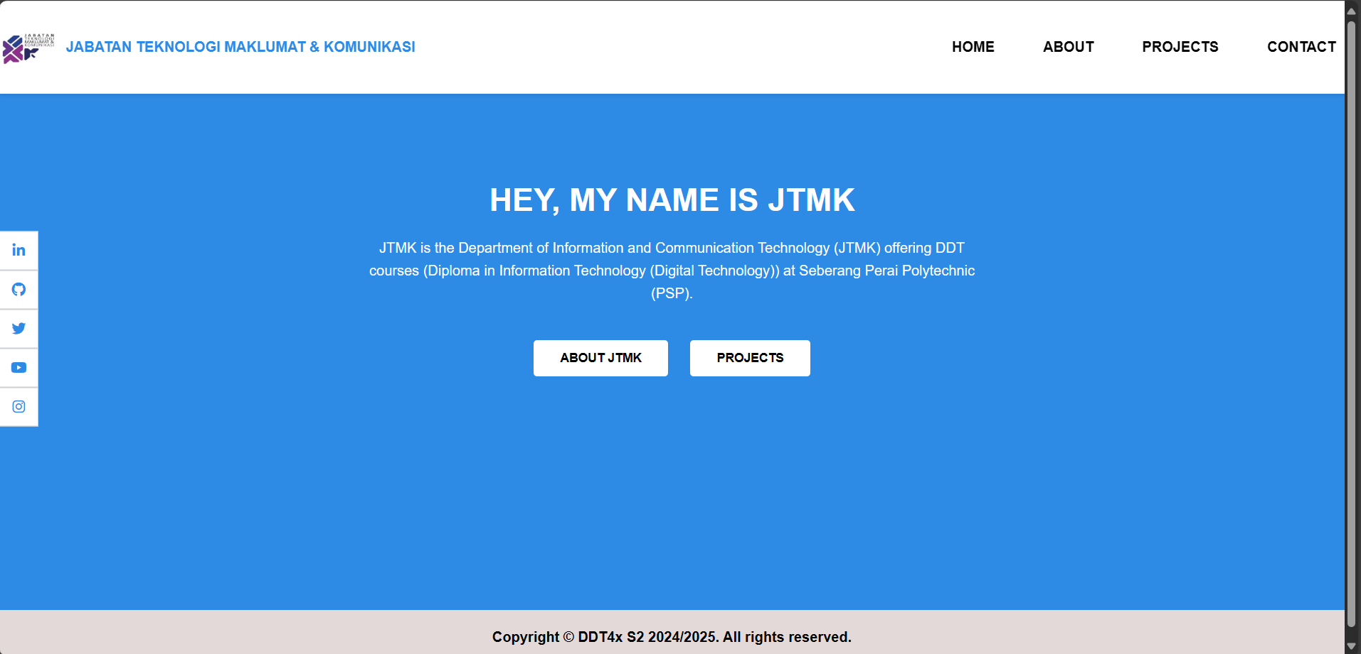
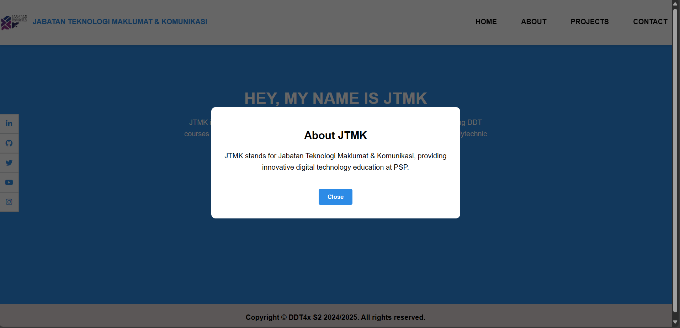
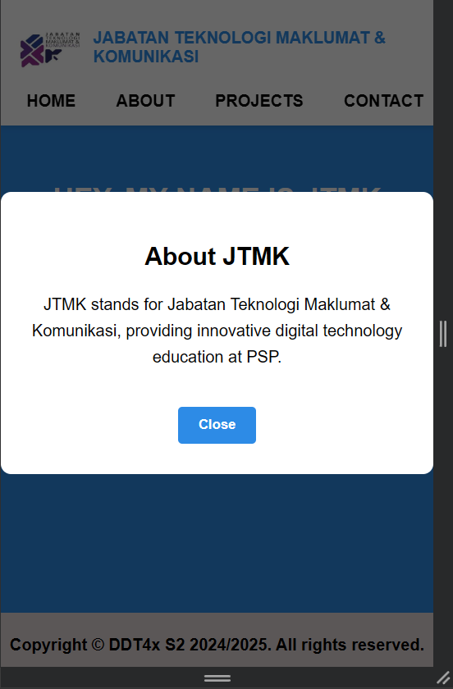
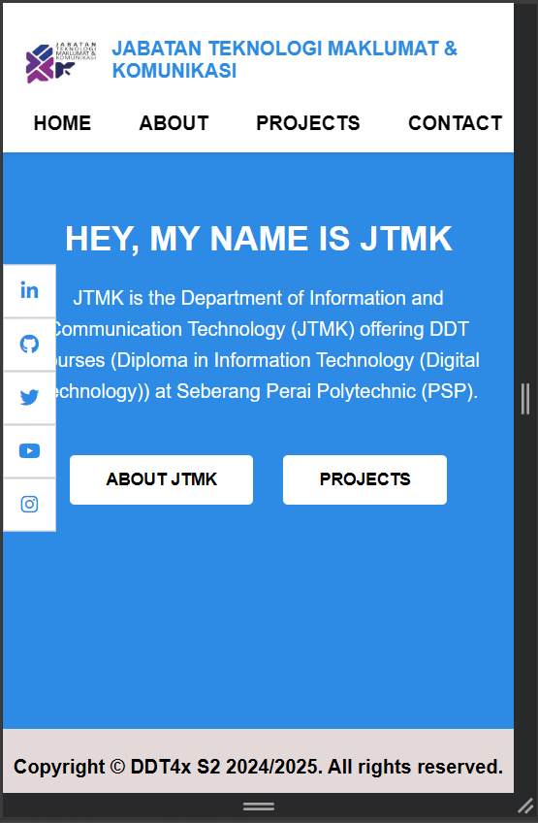

Answer Sheet:

Hosting (Project Files Hosted)
URL address:

Coding
Note: Font Type Consolas 10pt, Single Spacing
Specify the name of the html file followed by coding.

about.html
<!DOCTYPE html>
<html>

<head>
<meta charset="utf-8">
<meta name="viewport" content="width=device-width, initial-scale=1">
<title>JTMK - About</title>
<link rel="stylesheet" href="https://code.jquery.com/mobile/1.4.5/jquery.mobile-1.4.5.min.css">
<link rel="stylesheet" href="https://cdnjs.cloudflare.com/ajax/libs/font-awesome/6.0.0-beta3/css/all.min.css">
<style>
body {
margin: 0;
font-family: 'Poppins', sans-serif;
background-color: #f4f4f4;
}
.header {
color: #2d8be6;
display: flex;
justify-content: space-between;
align-items: center;
background-color: white;
padding: 20px 0px;
position: fixed;
top: 0;
width: 100%;
z-index: 1000;
box-shadow: 0 2px 5px rgba(0, 0, 0, 0.1);
}
.header .logo {
display: flex;
align-items: center;
}
.header .logo img {
height: 65px;
margin-right: 10px;
}
.header .nav a {
margin-left: 30px;
padding: 0 10px;
text-decoration: none;
color: black;
font-weight: 600;
font-size: 16px;
}
.header .nav a:hover {
color: #2d8be6;
}
.social-sidebar {
position: fixed;
top: 50%;
left: 0;
transform: translateY(-50%);
z-index: 999;
}
.social-sidebar a {
display: block;
padding: 10px;
background: #fff;
border: 1px solid #ccc;
text-align: center;
}
/* Profile Section Styling */
.team-container {
max-width: 1100px;
margin: 0 auto;
padding: 20px;
padding-top: 130px;
}
.team-container h2 {
text-align: center;
color: #2d8be6;
margin-bottom: 5px;
}
.team-container p {
text-align: center;
color: #555;
margin-bottom: 30px;
}
.team-grid {
display: flex;
flex-wrap: wrap;
gap: 30px;
justify-content: center;
}
.member-card {
background: #f9f9f9;
border-radius: 15px;
padding: 20px;
width: 250px;
text-align: center;
box-shadow: 0 4px 8px rgba(0, 0, 0, 0.1);
transition: transform 0.3s ease;
}
.member-card:hover {
transform: translateY(-5px);
}
.member-card img {
width: 100px;
height: 100px;
border-radius: 50%;
object-fit: cover;
margin-bottom: 15px;
}
.member-card h3 {
margin: 10px 0 5px;
color: #333;
}
.member-card h4 {
margin: 0;
font-size: 15px;
color: #666;
}
.member-card p {
font-size: 14px;
color: #444;
margin-top: 8px;
}
@media (max-width: 768px) {
.header {
flex-direction: column;
align-items: flex-start;
padding: 15px;
}
.header .nav {
margin-top: 10px;
}
.header .nav a {
margin-left: 0;
margin-right: 15px;
}
.main-content h1 {
font-size: 28px;
}
.main-content {
padding: 160px 20px 80px;
}
}
</style>
<script src="https://code.jquery.com/jquery-1.12.4.min.js"></script>
<script src="https://code.jquery.com/mobile/1.4.5/jquery.mobile-1.4.5.min.js"></script>
</head>
<body>
<!-- Social Sidebar -->
<div class="social-sidebar">
<a href="#"><i class="fab fa-linkedin"></i></a>
<a href="#"><i class="fab fa-github"></i></a>
<a href="#"><i class="fab fa-twitter"></i></a>
<a href="#"><i class="fab fa-youtube"></i></a>
<a href="#"><i class="fab fa-instagram"></i></a>
</div>
<!-- Header -->
<div class="header">
<div class="logo">
<img src="https://encrypted-tbn0.gstatic.com/images?q=tbn:ANd9GcROyv4Nw0BIjqcgF-J1VsyBbg3NfMots20uQQ&s"
alt="Logo" />
<h1 style="font-size:16px;margin:0;">JABATAN TEKNOLOGI MAKLUMAT & KOMUNIKASI</h1>
</div>
<div class="nav">
<a href="home.html" data-ajax="false">HOME</a>
<a href="about.html" data-ajax="false">ABOUT</a>
<a href="project.html" data-ajax="false">PROJECTS</a>
<a href="contact.html" data-ajax="false">CONTACT</a>
</div>
</div>
<!-- Redesigned Body Content -->
<div data-role="content" class="team-container">
<h2>Meet Our Team</h2>
<p>Details of the academic leaders at JTMK.</p>
<div class="team-grid">
<!-- Member 1 -->
<div class="member-card">
<img src="https://i.pinimg.com/736x/c9/e0/b5/c9e0b5e45aad1de8e27b25ec6ce3cd27.jpg" alt="Dr. Amina Yusuf">
<h3>Dr. Amina Yusuf</h3>
<h4>Head of Department</h4>
<p>Contact: +6012-3456789</p>
</div>
<!-- Member 2 -->
<div class="member-card">
<img src="https://i.pinimg.com/736x/a9/3d/b0/a93db08ff7305dfb4bd5fc8026f64e68.jpg" alt="Mr. Ahmad Zain">
<h3>Mr. Ahmad Zain</h3>
<h4>Program Head (Software Track)</h4>
<p>Contact: +6012-1234567</p>
</div>
<!-- Member 3 -->
<div class="member-card">
<img src="https://i.pinimg.com/736x/3e/f7/9a/3ef79aa4fda909d58ba9bf54d179d110.jpg" alt="Ms. Nurul Hana">
<h3>Ms. Nurul Hana</h3>
<h4>Program Head (Network Track)</h4>
<p>Contact: +6011-9876543</p>
</div>
<!-- Member 4 -->
<div class="member-card">
<img src="https://i.pinimg.com/736x/14/f1/96/14f196ffaff9d87d326d580629d0d0d5.jpg" alt="Mr. Lee Ming">
<h3>Mr. Lee Ming</h3>
<h4>Program Head (Data Track)</h4>
<p>Contact: +6010-1122334</p>
</div>
</div>
</div>
<!-- Footer -->
<div data-role="footer" data-position="fixed">
<h4>Copyright © DDT4x S2 2024/2025. All rights reserved.</h4>
</div>
</body>
</html>

Screenshot Interface:
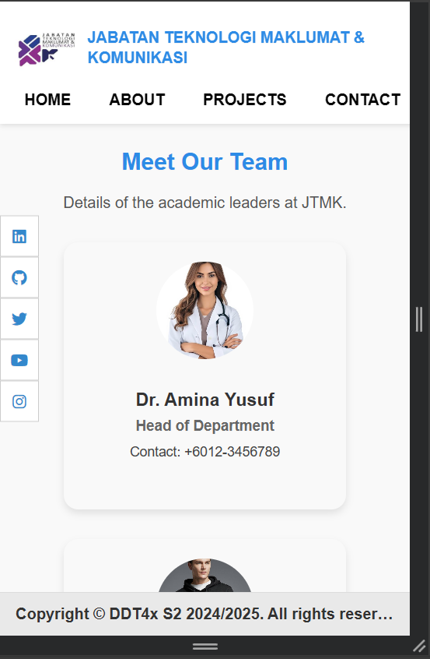
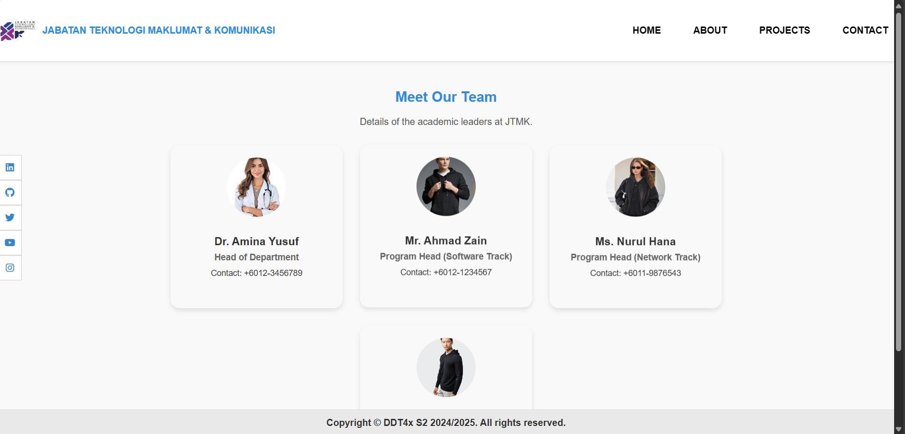

Answer Sheet:

Hosting (Project Files Hosted)
URL address:

Coding
Note: Font Type Consolas 10pt, Single Spacing
Specify the name of the html file followed by coding.
project.html
<!DOCTYPE html>
<html>

<head>
<meta charset="utf-8">
<meta name="viewport" content="width=device-width, initial-scale=1">
<title>JTMK Projects</title>
<!-- ✅ Font Awesome for social icons -->
<link rel="stylesheet" href="https://cdnjs.cloudflare.com/ajax/libs/font-awesome/6.0.0/css/all.min.css" />
<!-- jQuery Mobile & Fonts -->
<link rel="stylesheet" href="https://code.jquery.com/mobile/1.4.5/jquery.mobile-1.4.5.min.css">
<link href="https://fonts.googleapis.com/css2?family=Poppins:wght@300;400;600&display=swap" rel="stylesheet">
<!-- SweetAlert2 CDN -->
<script src="https://cdn.jsdelivr.net/npm/sweetalert2@11"></script>
<style>
body {
margin: 0;
font-family: 'Poppins', sans-serif;
background-color: #f4f4f4;
}
.header {
color: #2d8be6;
display: flex;
justify-content: space-between;
align-items: center;
background-color: white;
padding: 20px 0px;
position: fixed;
top: 0;
width: 100%;
z-index: 1000;
box-shadow: 0 2px 5px rgba(0, 0, 0, 0.1);
}
.header .logo {
display: flex;
align-items: center;
}
.header .logo img {
height: 65px;
margin-right: 10px;
}
.header .nav a {
margin-left: 30px;
padding: 0 10px;
text-decoration: none;
color: black;
font-weight: 600;
font-size: 16px;
}
.header .nav a:hover {
color: #2d8be6;
}
.main-content {
padding-top: 120px;
padding-bottom: 60px;
text-align: center;
}
.main-content h2 {
margin-bottom: 20px;
font-size: 32px;
font-weight: 600;
color: #333;
}
.main-content p {
font-size: 16px;
color: #555;
margin-bottom: 30px;
}
.project-container {
display: flex;
flex-wrap: wrap;
justify-content: center;
gap: 20px;
padding: 0 20px;
}
.project-item {
background: white;
border-radius: 10px;
box-shadow: 0 4px 10px rgba(0, 0, 0, 0.1);
max-width: 300px;
overflow: hidden;
transition: transform 0.3s;
}
.project-item:hover {
transform: scale(1.05);
}
.project-item img {
width: 80px;
height: 70px;
object-fit: cover;
border-bottom: 2px solid #ddd;
margin-top: 10px;
}
.project-item h3 {
font-size: 22px;
margin: 10px;
color: #333;
font-weight: 600;
}
.project-item p {
font-size: 15px;
color: #555;
padding: 0 15px;
}
.project-item .view-report {
display: inline-block;
margin: 15px;
padding: 10px 20px;
background-color: #007aff;
color: white;
text-decoration: none;
border-radius: 5px;
font-weight: 600;
font-size: 14px;
transition: background-color 0.3s;
}
.project-item .view-report:hover {
background-color: #005bb5;
}
footer,
.ui-footer h4 {
font-size: 16px;
font-weight: 300px;
color: black;
text-align: center;
padding: 10px 0;
}
/* ✅ Social Media Sidebar */
.social-sidebar {
position: fixed;
top: 50%;
left: 0;
transform: translateY(-50%);
display: flex;
flex-direction: column;
z-index: 999;
}
.social-sidebar a {
padding: 12px;
color: #2d8be6;
background: #fff;
border: 1px solid #ccc;
text-align: center;
transition: background 0.3s;
}
.social-sidebar a:hover {
background: #f0f0f0;
}
@media (max-width: 768px) {
.header {
flex-direction: column;
align-items: flex-start;
padding: 15px;
}
.header .nav {
margin-top: 10px;
}
.header .nav a {
margin-left: 0;
margin-right: 15px;
}
.main-content h1 {
font-size: 28px;
}
.main-content {
padding: 160px 20px 80px;
}
}
</style>
<script src="https://code.jquery.com/jquery-1.12.4.min.js"></script>
<script src="https://code.jquery.com/mobile/1.4.5/jquery.mobile-1.4.5.min.js"></script>
</head>
<body>
<!-- ✅ Social Sidebar -->
<div class="social-sidebar">
<a href="#"><i class="fab fa-linkedin"></i></a>
<a href="#"><i class="fab fa-github"></i></a>
<a href="#"><i class="fab fa-twitter"></i></a>
<a href="#"><i class="fab fa-youtube"></i></a>
<a href="#"><i class="fab fa-instagram"></i></a>
</div>
<!-- Header -->
<div class="header">
<div class="logo">
<img src="https://encrypted-tbn0.gstatic.com/images?q=tbn:ANd9GcROyv4Nw0BIjqcgF-J1VsyBbg3NfMots20uQQ&s"
alt="Logo" />
<h1 style="font-size:16px;margin:0;">JABATAN TEKNOLOGI MAKLUMAT & KOMUNIKASI</h1>
</div>
<div class="nav">
<a href="home.html" data-ajax="false">HOME</a>
<a href="about.html" data-ajax="false">ABOUT</a>
<a href="project.html" data-ajax="false">PROJECTS</a>
<a href="contact.html" data-ajax="false">CONTACT</a>
</div>
</div>
<!-- Main Content -->
<div class="main-content">
<h2>Our Upcoming Projects</h2>
<p>Explore the innovative projects we have developed to improve systems and create impactful solutions.</p>
<div class="project-container">
<!-- Project 1 -->
<div class="project-item">
<a href="example" target="_blank">
<img src="https://www.shutterstock.com/image-vector/hand-touch-fingerprint-bio-metric-260nw-1803151870.jpg"
alt="Smart Attendance System">
</a>
<div class="project-info">
<h3>Smart Attendance System</h3>
<p>A smart solution to track attendance using QR codes and facial recognition technology.</p>
<a href="javascript:void(0)" onclick="showSuccessMessage()" class="view-report">View Report
(PDF)</a>
</div>
</div>
<!-- Project 2 -->
<div class="project-item">
<img src="https://encrypted-tbn0.gstatic.com/images?q=tbn:ANd9GcRj001nlmt02hpn9v0UhhNsXSvF9sVtOONMhw&s"
alt="Volunteer Management System">
<div class="project-info">
<h3>Volunteer Management System</h3>
<p>A comprehensive system to manage volunteer data, track attendance, and generate reports.</p>
<a href="javascript:void(0)" onclick="showSuccessMessage()" class="view-report">View Report
(PDF)</a>
</div>
</div>
</div>
</div>
<!-- Footer -->
<div data-role="footer" data-position="fixed">
<h4>Copyright © DDT4x S2 2024/2025. All rights reserved.</h4>
</div>
<script>
// Function to show success message when "View Report" is clicked
function showSuccessMessage() {
Swal.fire({
title: "Good job!",
text: "You have viewed the report!",
icon: "success"
});
}
</script>
</body>
</html>

Screenshot Interface:
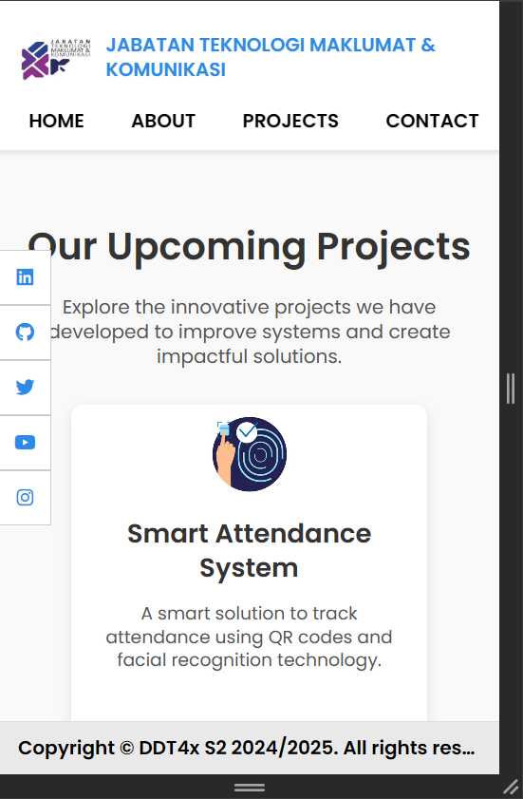
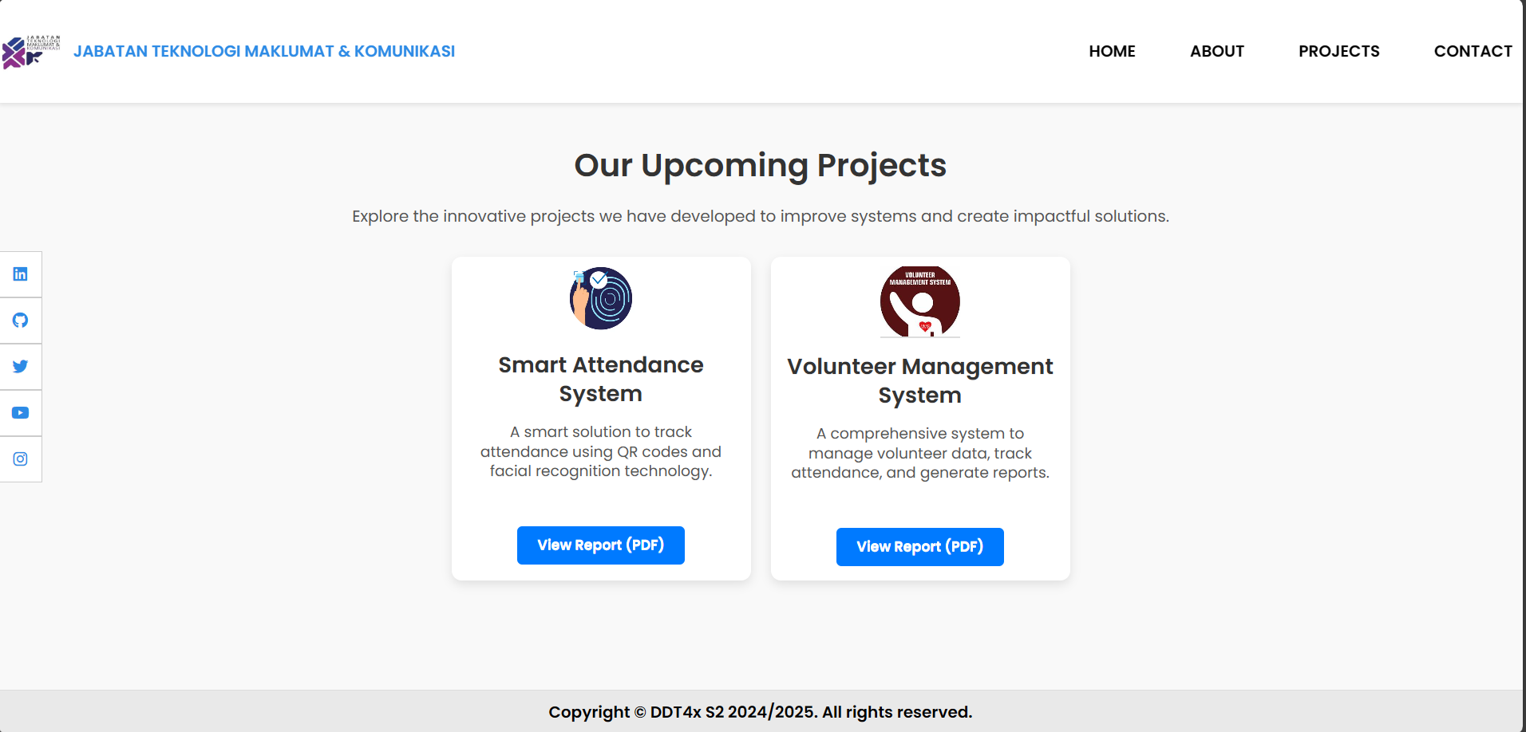

Answer Sheet:

Hosting (Project Files Hosted)
URL address:

Coding
Note: Font Type Consolas 10pt, Single Spacing
Specify the name of the html file followed by coding.
project.html
<!DOCTYPE html>
<html>

<head>
<meta charset="utf-8">
<meta name="viewport" content="width=device-width, initial-scale=1">
<title>Contact - JTMK Mobile Site</title>
<link rel="stylesheet" href="https://code.jquery.com/mobile/1.4.5/jquery.mobile-1.4.5.min.css">
<link rel="stylesheet" href="https://cdnjs.cloudflare.com/ajax/libs/font-awesome/6.0.0-beta3/css/all.min.css">
<style>
body {
margin: 0;
font-family: 'Poppins', sans-serif;
background-color: #f4f4f4;
}
.header {
color: #2d8be6;
display: flex;
justify-content: space-between;
align-items: center;
background-color: white;
padding: 20px 0px;
position: fixed;
top: 0;
width: 100%;
z-index: 1000;
box-shadow: 0 2px 5px rgba(0, 0, 0, 0.1);
}
.header .logo {
display: flex;
align-items: center;
}
.header .logo img {
height: 65px;
margin-right: 10px;
}
.header .nav a {
margin-left: 30px;
padding: 0 10px;
text-decoration: none;
color: black;
font-weight: 600;
font-size: 16px;
}
.header .nav a:hover {
color: #2d8be6;
}
/* Social Sidebar */
.social-sidebar {
position: fixed;
top: 50%;
left: 0;
transform: translateY(-50%);
z-index: 999;
}
.social-sidebar a {
display: block;
padding: 10px;
background: #fff;
border: 1px solid #ccc;
text-align: center;
}
@media (max-width: 768px) {
.header {
flex-direction: column;
align-items: flex-start;
padding: 15px;
}
.header .nav {
margin-top: 10px;
}
.header .nav a {
margin-left: 0;
margin-right: 15px;
}
.main-content h1 {
font-size: 28px;
}
.main-content {
padding: 160px 20px 80px;
}
}
</style>
<script src="https://code.jquery.com/jquery-1.12.4.min.js"></script>
<script src="https://code.jquery.com/mobile/1.4.5/jquery.mobile-1.4.5.min.js"></script>
</head>
<body>
<!-- Social Sidebar -->
<div class="social-sidebar">
<a href="#"><i class="fab fa-linkedin"></i></a>
<a href="#"><i class="fab fa-github"></i></a>
<a href="#"><i class="fab fa-twitter"></i></a>
<a href="#"><i class="fab fa-youtube"></i></a>
<a href="#"><i class="fab fa-instagram"></i></a>
</div>
<!-- Header -->
<div class="header">
<div class="logo">
<img src="https://encrypted-tbn0.gstatic.com/images?q=tbn:ANd9GcROyv4Nw0BIjqcgF-J1VsyBbg3NfMots20uQQ&s"
alt="Logo" />
<h1 style="font-size:16px;margin:0;">JABATAN TEKNOLOGI MAKLUMAT & KOMUNIKASI</h1>
</div>
<div class="nav">
<a href="home.html" data-ajax="false">HOME</a>
<a href="about.html" data-ajax="false">ABOUT</a>
<a href="project.html" data-ajax="false">PROJECTS</a>
<a href="contact.html" data-ajax="false">CONTACT</a>
</div>
</div>
<!-- Content Section -->
<div data-role="content" class="content-center" style="padding-top: 120px;">
<a href="tel:+60123456789" class="ui-btn ui-icon-phone ui-btn-icon-left">Call Us</a>
<a href="mailto:info@jtmk.edu.my" class="ui-btn ui-icon-mail ui-btn-icon-left">Email Us</a>
<a href="https://wa.me/60123456789" class="ui-btn ui-icon-comment ui-btn-icon-left">WhatsApp</a>
</div>
<!-- Footer -->
<div data-role="footer" data-position="fixed">
<h4>Copyright © DDT4x S2 2024/2025. All rights reserved.</h4>
</div>
</body>
</html>

Screenshot Interface:
